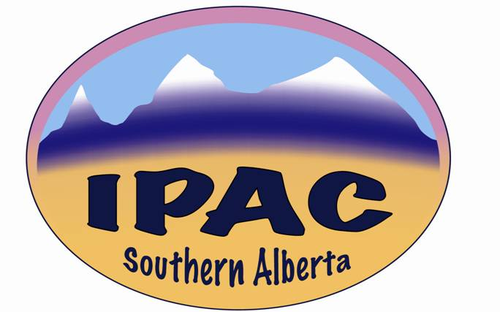

**IPAC – Southern Alberta**

**MINUTES**

**Date**: Wednesday, October 11, 2023

**Venue**: Virtual

**Time**: 14:00 – 15:00

**Present**: Gordon Platt, Zaheeda Jessani, Jason Morris, Megan Smith, Vinita Kumar, Chelsea Hagg, Rhonda DeMarco, Lisa Chu, Roberta McCombie, Shanthi Anchan, Hitesh Patel, Kim Houde, Kaethel Decker, Suzanne Pinfield, Lemlem Ghebreyesus, Lori Pohl, Lorinder Stuber, Jennifer Ellison, Louise Curammeng, Nicole Anderson, Obeleye Tamuno, Victoria Dueck, Josephine Kalunga, Gwyneth Meyers, Carlie King, Jennifer Happe, Gisele Saulnier, Kimberly Lillington, Kormelija Delibasic (visiting speaker).

**Absent with Apologies**: Janeth Ty, Jef Jurgeneit, Kristine Cannon.

The President, Kim Houde, called meeting to order at 14:04.

**Education Component**

Jason Morris introduced Kormelija, who introduced Bay River College and gave an overview of the college’s IPC program.

After the presentation, the President gave a summary of IPC education programs available, and that it was up to anyone interested to pursue and contact them individually. Kormelija may be contacted at: [kormelijad@icloud.com](mailto:kormelijad@icloud.com), 416-994-2660, 403-457-6400.

**Business Component**

President’s Report (Kim Houde)

This being the first meeting after the summer, the President had no update to give.

Treasurer’s Report (Kris Cannon)

No report, Treasurer was not in attendance.

Elections

The President conducted this session. Nominations were provided via email to the chapter’s email account ([southernalberta.ipac@gmail.com](mailto:southernalberta.ipac@gmail.com)). Positions were acclaimed and successful nominees are:

Treasurer - Kristine Cannon (maintaining current role)

Secretary - Jason Morris

Education Coordinator - Megan Smith

Social Media & Webmaster - Michelle Platt

President – Chelsea Hagg

Past President - Kim Houde

Membership Director – This position has been vacant for a long time. The Executive has been running membership affairs. No names were submitted for this position.

As there was no competition, the above names were unanimously approved, and messages of congratulations posted in the chat box.

Incoming President, Chelsea Hagg, thanked the outgoing office, and stated that she was looking forward to working with the new office and the general membership.

Kim Houde requested anyone, especially from Red Deer/Central Zone, who would be interested in the vacant Membership Director position to submit their name for consideration.

Nicole Anderson wondered if the chapter has ever had an in-person meeting, where there was attendance from the different cities and Zones.

In response, Kim Houde said all meetings used to be face to face, but they ended up being very Calgary-centric. And that when she assumed office, she endeavored to engage Central and South zones more. Thus, the move to Telehealth and two face-to-face meetings, with lunch per year.

Gwyneth Meyers gave a bit more historical perspective to the question, going back to pre-AHS days. That they used to meet at the old Calgary General Hospital, where ICPs from Calgary and Red Deer attended. Then at the Fanning Centre, which then expanded to include continuing care and rural ICPs. After that, meetings moved to Red Deer.

Gwyneth continued that when the Health Regions were amalgamated into AHS, ICPs started meeting at many different fora, which negated the need for dedicated meetings. The need to expand beyond AHS ICPs and to include other stakeholders led to where we currently are.

Kim Houde agreed that the chapter is still largely AHS/ICP-focused and has initiated moves to reach out to other sectors, such as physicians in private practice, dentists’ offices, and physiotherapy. Gisele Saulnier confirmed that she is from Environmental Public Health, having recently transferred into this department. Members were asked to reach out and promote the organization and chapter in their interactions.

Joseph Kaunda asked if there was an associate membership, given that we are having colleges starting to show interest.

Kim Houde stated that there is none as at now, currently having active, retired, student and industry memberships, but that it is a good idea to promote the organization and IPC practice among students when we interact with them.

**Interest Group Reports**

EHIG Report (Gord Platt)

*Per our meeting today, the last Environmental Hygiene Interest Group meeting was mid June, just after the IPAC Canada National Conference in Vancouver.  
Meena Mulhotra,IPAC EHIG Chair provided a summary update of the lectures from the IPAC Canada conference…the Diversey Cleaning/Disinfection 1/2 day Symposium.  
Guest speakers and topics:  
1.  Dr. Michelle Alfa (Winnipeg), dry biofilms and suggested recommendations.  
2.  Dr. Victor Leung (Vancouver), Candida Auris updates, surveillance.  
3.  Natalie Bruce (Ottawa), Environmental auditing and positive reinforcement model for process improvement.  
4. Jim Gauthier (Kingston), Horizontal Infection Prevention and guidance.  
  
The education session for the meeting was provided by Hailey Smitten, AHS and she provided insight to the Environmental Audit tool AHS uses with a dashboard via Westech (third party contract)…positive reinforcement is key to their success on auditing environmental surfaces.****The next EHIG interest group meetings will be on:***

***October 12:  Natasha Salt CIC (Kingston) CPE Surveillance and environmental hygiene impact.  
November 9:  Dr. Diddier Pitet Clean Hands, Clean Hospitals.***

There being no further items for discussion, Kim adjourned the meeting at 14:48.

Next meeting: December 6, 2023. Face-to-face, 1200 – 1500. Details to be availed.